Desktop/Laptop

Application

Supervisor Guide

Pacific Timesheet

Step 1
Log into the timesheet system
- Go to the Login Page:

  - Open browser: (Internet Explorer, Edge, Chrome, Firefox, or Safari)
  - Enter URL: https://eval__.pacifictimesheet.com (modify URL to match your system’s URL)
  - Save URL: save to browser favorites

Figure 1: Login Page
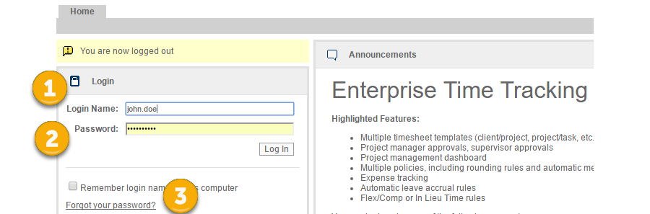

  - Enter Login Name: Enter your login name (See 1 above).
  - Enter Password: Enter your initial password: 12345 (See 2 above).
  - New Password Prompt: The system will prompt you to change your password to a unique password.
  - Forgot your password: (see 3 above) If you forget your password, click on the “forgot your password?” link and enter your login name, email address or employee ID. A new temporary password will be emailed to you.
  - New Employee: When beginning as a new user in the system, you can gain access to the system as follows:
    - You will receive a starter email with a link to this system page:
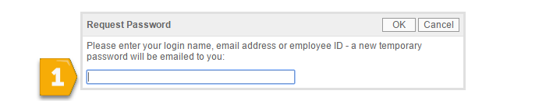

    - Follow the instructions and enter your login name, system email address or employee ID (See 1 above).

    - A temporary password will be emailed to you.

    - Return to the login page, login using this temporary password.

    - The system will prompt you to reset your password.

Store your new password for safekeeping and future use. Remember, if you forget your password you can always reset it using the “forgot password” link.
Step 2
Overview of Approver Tabs

- There are several important system tabs for Supervisors.
  - Home: identical to an ordinary user’s home page.
  - My Timesheet: your timesheet (See User Guide).
  - Approvals: where you approve timesheets of your direct reports and do backup approvals.
  - Reports: where you can run reports on your employee’s timesheet data.

Figure 2: Supervisor Tabs

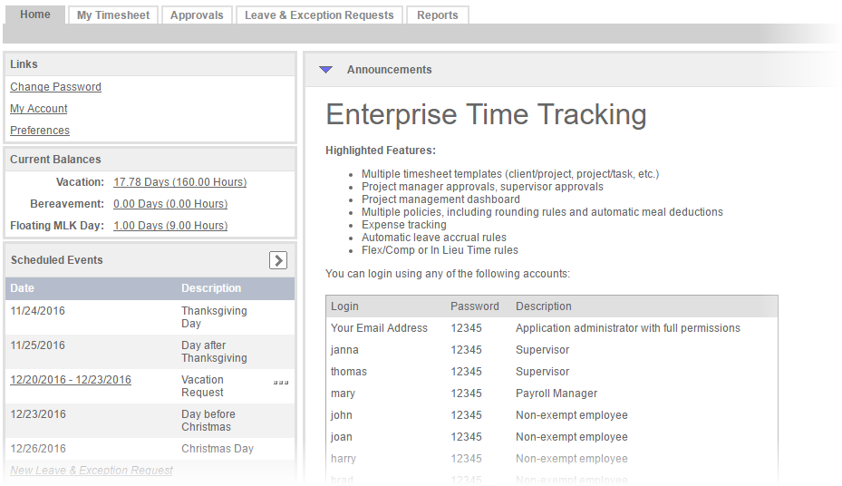
Step 3
Approving Timesheets

- Overview: You can do primary approvals of the timesheets of your direct reports and backup approvals for other employees using the approval dashboard.

  - Time Period Picker: You can browse through various preset time periods (See 1 below). These include usable presets such as This Week, Previous Week, etc.
  - Status: (See 2) Allows you to search for timesheets by status such as Open, Submitted, etc.
  - Search: (See 3) Click on search to redraw the approval dashboard according to new settings such as Status = Open, Time Period = Last 90 Days. Select your new settings and click on Search and the approval dashboard will sort timesheets accordingly. To clear these settings click Clear.
  - Viewing Summary Timesheet Data: The Approver Tab renders summary data such as Total Hours broken out by Work and Leave Hours. Scheduled Leave totals have their own column. When Scheduled Leave hour totals do not match actual Leave hours entered on an employee’s timesheet, they will appear in red.
  - Approval: You can approve a timesheet at the summary level by clicking the approval check box.
  - Approval Details: By clicking on the timesheet period link for an employee (see 4), you can view the employee’s timesheet in a line item details view. This view allows you to reject one-time entry with a reason. Click on save and the employee will be notified by email of the rejection and your reason.

Figure 3: Timesheet Approvals Dashboard
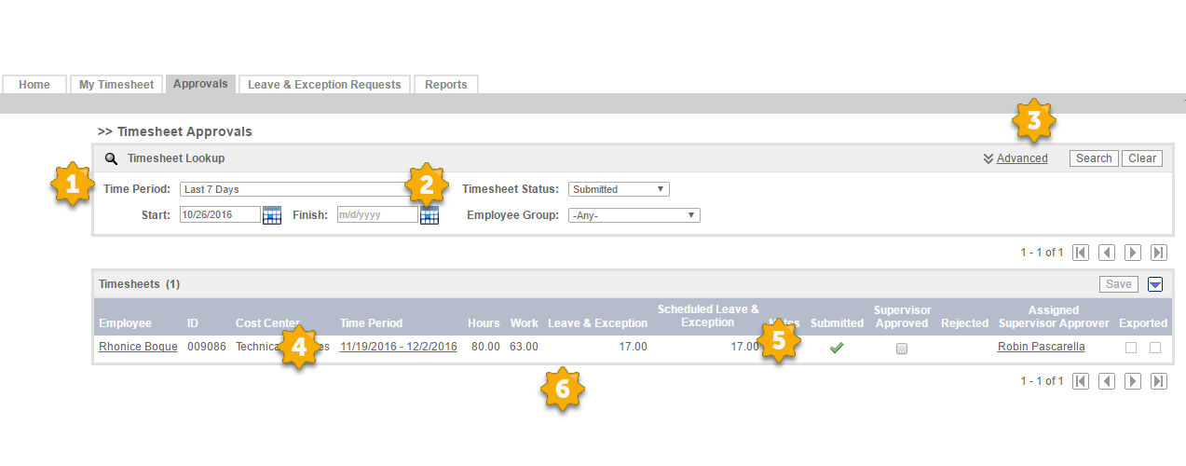

  - Advanced Filter: (See 3) You can click on Advanced to be able to view your backup approvals and also to search by employee.

Figure 4: Timesheet Approval Details Page

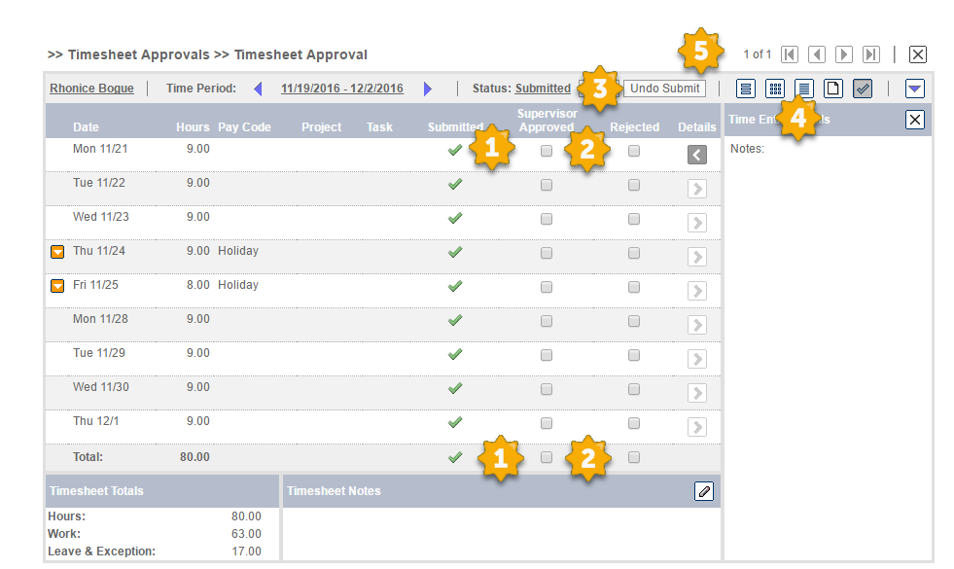

  - Views: (See 4 above) Your default view after drilling down to look at a timesheet is the approval view (which is a checkmark button). However, you can also get “over the shoulder” views of employee timesheets by click on the week view, day, summary view buttons. These function as they do for employees on their timesheets.
  - VCR Controls: (See 5) You can approve or reject timesheets in the details view and then click on the forward button to go to the next timesheet. You can also go backwards, to the beginning or end of your timesheets.
  - Rejecting Line Items: (See 2) You can reject time entries with a reason. Or, you can reject the entire timesheet with a reason by clicking on the rejected checkbox on the total row.

  - Approving Line Items: You can approve line items or all time entries by clicking on the approval checkbox on the total row (See 1).
  - Time Entry Details: You can view time entry details by clicking on the Details button for any row.
  - Unsubmit: If you have the necessary permissions, you can unsubmit and edit the user’s timesheet (See 3).
  - Reminders: You will receive automated reminders by email when you are to approve timesheets and late notices when you are past due on making these approvals.

Step 4
Approving Leave
- Overview: When an employee makes a Leave request you will receive an email notification. Click on the Leave Requests tab to approve employee Leave requests.

  - Leave Request Approval Dashboard: This dashboard has the following features:

Figure 5: Leave Request Dashboard

    - Date Search: You can search for leave requests by picking a start and end date and clicking on search.
    - Request Type: You can filter requests by type such as vacation, sick, etc.
    - Other Filters: You can filter requests by Status and by using the Advanced filter. These features match those of the Timesheet Approval Dashboard.

  - Drilling into Request: You can click on the request link and view the details of the request. Approve or reject the request with a reason. An email notification will be sent to the employee with your rejection and reason.
  - Check the Balance: Make sure that the employee has enough of a balance to support the request. You can view the projected balance on the date of the request. If the request will make the employee balance go negative, the balance will display in red. Such requests should be rejected.

Figure 6: Leave Request Approval Page

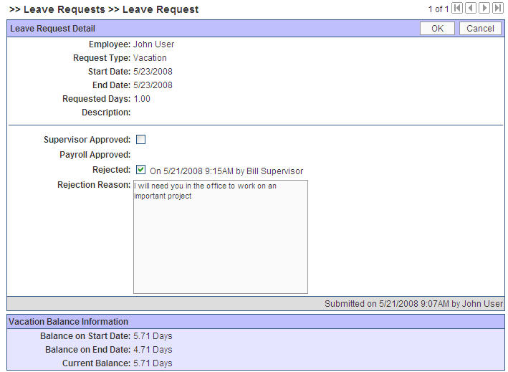

Step 5
Notices
- Overview: Pacific Timesheet provides various tools that make it easier to manage and monitor employee timesheet compliance and hours.

  - Reminders and Lateness notifications: Pacific Timesheet automatically reminds employees of when their timesheets are due and when they are late. You as a Supervisor will also be reminded when your timesheet approvals are due and when they are late.

If you have any more detailed questions, refer to the Approvals and Leave Requests Online Help topics or contact your manager or system administrator.

