Desktop/Laptop

Application

Project Manager
User Guide

Pacific Timesheet

- Introduction
The Pacific Timesheet web-based timesheet system allows Project Managers to monitor and approve project hours by tasks or other work items (activities, phases, etc.).

What You Do
Step 1
Log into the timesheet system

- Go to the Login Page:

  - Open browser: (Internet Explorer, Firefox, or Safari)
  - Enter URL provided by your manager
  - Save URL: save to browser favorites
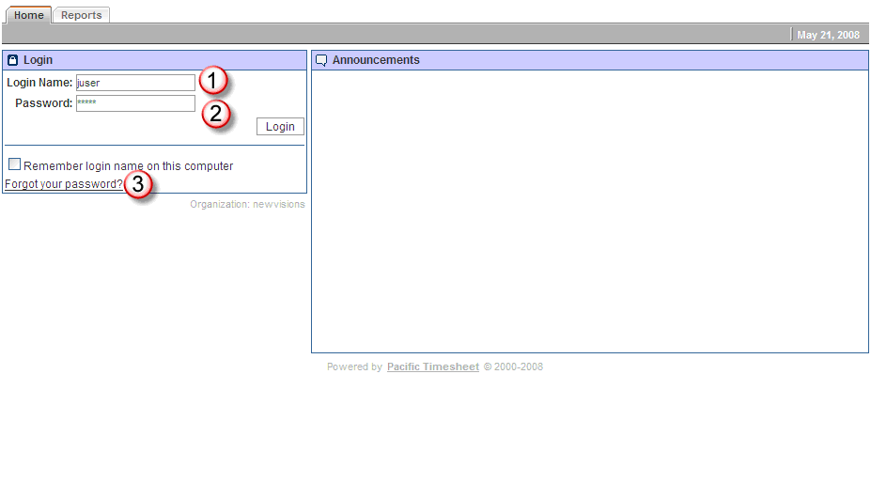

  - Enter Login Name: Enter your login name (See 1 above).
  - Enter Password: Enter your initial password: 12345 (See 2 above).
  - New Password Prompt: The system will prompt you to change your password to a unique password.
  - Forgot your password: (see 3 above) If you forget your password, click on the “forgot your password?” link and enter your login name, email address or employee ID. A new temporary password will be emailed to you. In fact, if you are a new user, and know you have been setup in the system, you can always reset your password by following the instructions on this forgot password page as well.

Step 2
Overview of Approver Tabs

- There are several important system tabs for Project Managers.
  - Home: identical to an ordinary user’s home page.
  - My Timesheet: your timesheet (See User Guide).

  - Approvals: where you approve project time of employees working on your projects.
.
  - Reports: where you can run reports on your project’s data.

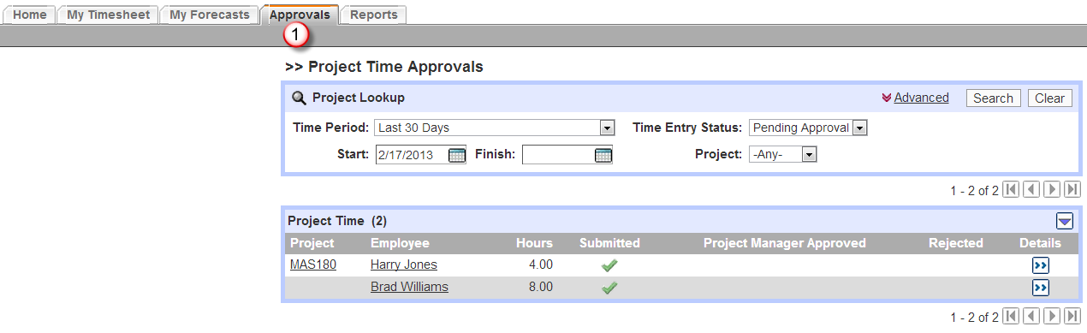
Step 3
Approving Project Time

- Overview: You can approve project time using the project time approval dashboard.

  - Time Period Picker: You can browse through various preset time periods (See 1 below). These include usable presets such as This Week, Previous Week, etc.
  - Status: (See 2) Allows you to search for timesheets by status such as Open, Submitted, etc.
  - Search: (See 3) Click on search to redraw the approval dashboard according to new settings such as Status = Open, Time Period = Last 90 Days. Select your new settings and click on Search and the approval dashboard will sort timesheets accordingly. To clear these settings click Clear.
  - Advanced Filter: You can click on Advanced to be able to view your backup approvals and also to search by employee (shown above).
  - Project Manager Approval: At a summary level you can view employee project hours without drilling down.
  - Employee Contact Number: To find the primary telephone contact number of the employee click on the employee’s name (See 4).
  - Drilling Into Project Time: To approve project time, click on the Details button on the right of an employee project time row.

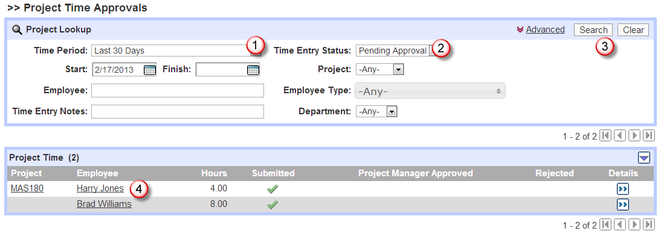

  - Approving/Rejecting Project Time Entries: To approve or reject project time entries, check the appropriate row(s) and then click Approve or Reject. You can go back to summary level by click on the [x] in the right hand corner of this page.

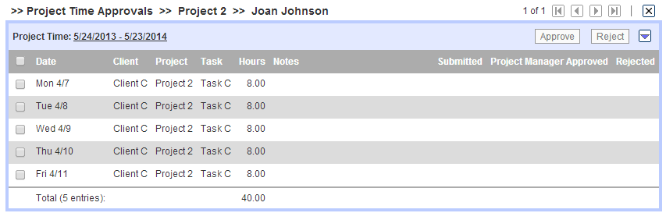

  - VCR Controls: (See Above) You can approve or reject project entries for each employee in this project details view. When finished you can click on the forward button to go to the next employee’s project time entries for that project. You can also go backwards, to the beginning or end of your employee project time entries.
  - Rejecting Line Items: (See Below) You can reject one time entry with a reason. Or, you can reject the entire timesheet with a reason by clicking on the rejected checkbox on the total row.

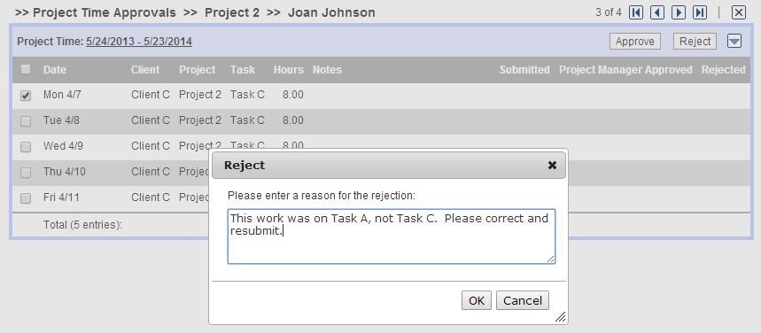

  - Approving Line Items: You can approve line items or all time entries by clicking on the approval checkbox on the total row (See Above).
  - Reminders: You will receive automated reminders by email when you are to approve project time entries and late notices when you are past due on making these approvals.

Step 4
Notices
- Overview: Pacific Timesheet provides various tools that make it easier to manage and monitor employee timesheet compliance and hours.

  - Reminders and Lateness notifications: Pacific Timesheet automatically reminds employees of when their timesheets are due and when they are late. You as a Project Manager will also be reminded when your project time approvals are due.

If you have any more detailed questions, contact your manager or system administrator.

