User Guide

Pacific Timesheet

Step 1
Log into the timesheet system

- Go to the Login Page:

  - Open browser: (Internet Explorer, Edge, Chrome, Firefox, or Safari)
  - Enter URL: https://eval___.pacifictimesheet.com
  - Save URL: save to browser favorites

Figure 1: Login Page
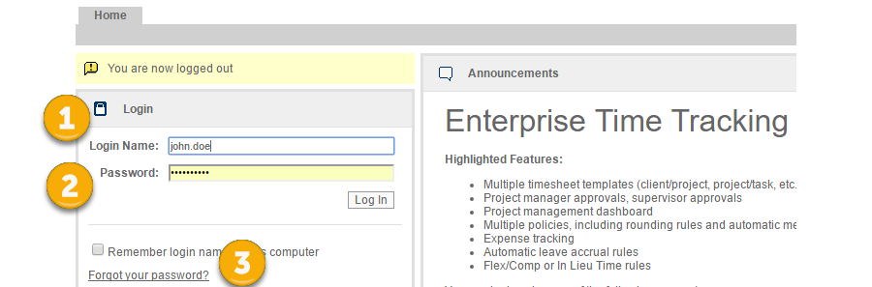

  - Enter Login Name: Enter your login name (See 1 above).
  - Enter Password: Enter your initial password: 12345 (See 2 above).
  - New Password Prompt: The system will prompt you to change your password to a unique password.
  - Forgot your password: (see 3 above) If you forget your password, click on the “forgot your password?” link and enter your login name, email address or employee ID. A new temporary password will be emailed to you.
  - New Employee: When beginning as a new user in the system, you can gain access to the system as follows:
    - You will receive a starter email with a link to this system page:
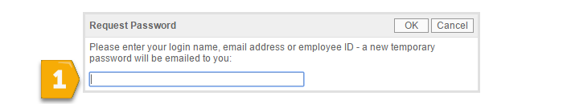

    - Follow the instructions and enter your login name, system email address or employee ID (See 1 above).

    - A temporary password will be emailed to you.

    - Return to the login page, login using this temporary password.

    - The system will prompt you to reset your password.

    - Store your new password for safekeeping and future use. Remember, if you forget your password you can always reset it using the “forgot password” link.
Step 2
Set Preferences

- Set Password, My Account and Preferences: You can control various preferences for your user account and how your timesheet will behave. These include password settings, contact information, the length of search list results, your default page after login and the number of work items your timesheet will remember.
Figure 2: Key User Links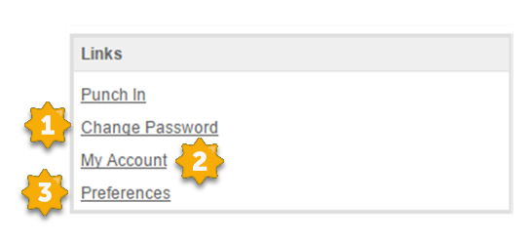

  - Change your password: (See 1 above) Enter your current password and enter a new password
  - View your account: You can view basic information about your user record. Verify that your contact information and email address are correct:
    - First Name
    - Last Name
    - Email
    - Phone
    - Mobile
    - Fax
    - Timesheet Rows
    - Time Entry Format

Step 3
Requesting Leave

- Home Page Overview: From your home page you can view general announcements, check your available Leave balances, request leave and check your calendar for upcoming approved leave and organization holidays.

Figure 3: Home Page

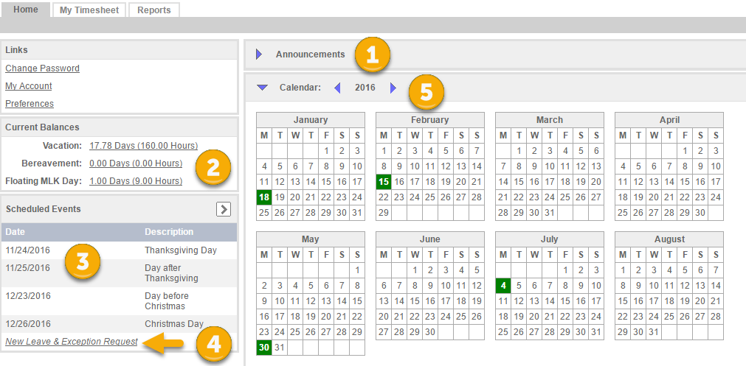

  - View Announcements: You can view general announcements. You can click on the show/hide button to collapse or display this area (See 1).
  - Checking Leave: On the home page your available Leave is displayed under Current Balances (See 2).
  - Scheduled Events: Your scheduled events, such as holidays, leave requests and approved leave (See 3).
  - Request Leave: Click this link to request new Leave (See 4).
    - A Leave Request Form displays (See below). Complete the form with beginning and end date of Leave Request.

Figure 4: Leave Request Form

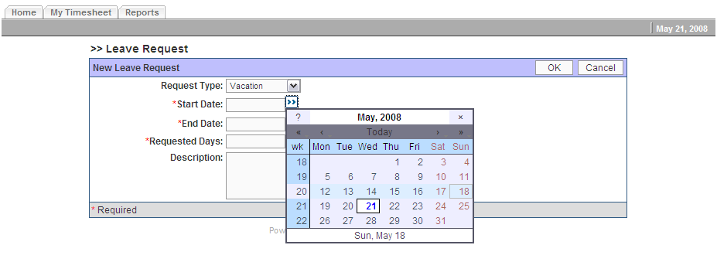

    - Submit the form.
    - Do a final check to make sure you have available Leave for the request on the dates you need the Leave. If you do not your Supervisor will probably not approve the request (See below).

Figure 5: Leave Request Validation

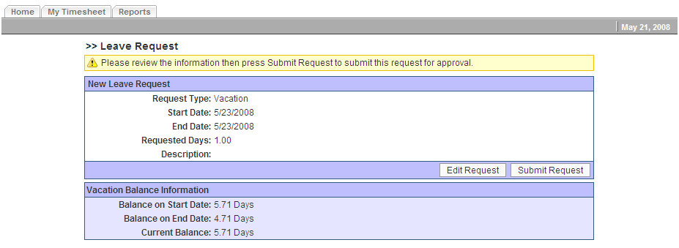

  - Pending Leave: While waiting for your Supervisor to approve your Leave request it will display as a pending request on the vertical list (see below)

Figure 6: Scheduled Events
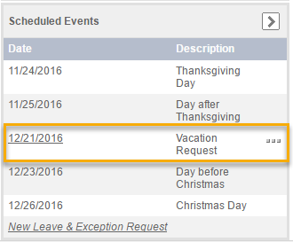

  - Approved and Rejected Leave Requests: After your Supervisor approves your Leave request it will display on your vertical list with a green check mark. If it is rejected it will display with a red X. If rejected, you can drill into the rejected Leave Request to learn the reason why it was rejected by your Supervisor.

Figure 7: Approved/Rejected Leave Requests

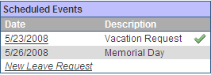

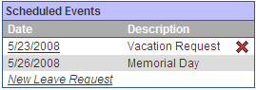

Figure 8: Leave Request Details/Comments

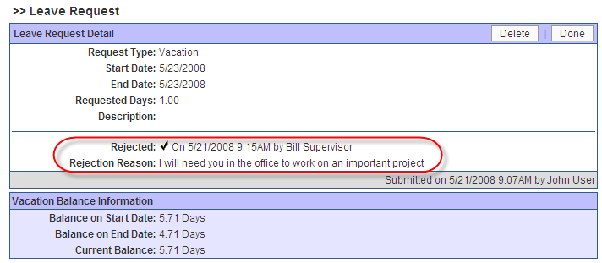

  - Calendar: Your upcoming holidays and approved also display on the calendar. Today’s date has bold border around it (see 5 above).

Step 4
Using Timesheets
- Overview: Depending upon your timesheet form, you can enter your Start/Finish times, Hours, Work Items, work item properties such as Call Out, notes, and Time Off on your timesheet. You can also submit the timesheet, track its status and navigate around the system to past timesheets for reference.

  - Adding Work Items: You can select appropriate Work Items using a selector dialog, and later by using pick lists with previously used Work Items. After clicking on the My Timesheet tab, add rows to your timesheet by clicking on Add Work. While you can add as many work rows as you need, remember only to add and manage the rows you need or your timesheet will become cluttered and more difficult to use.

    - Finding Work Items: For each row of the timesheet, you will enter your hours by Work Item. For example, you can browse and search for your project. The first time you do this, hit the browse link to find the appropriate Work Item in the work item dialog.

Figure 8: Work Item Pick List & Browse

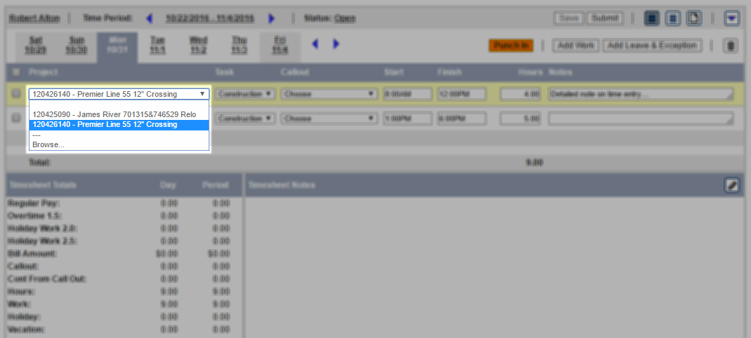

    - Search Utility: Start typing in the search box and the system will start to return a filtered list of work items. You can search by work item name, ID or description.
Figure 9: Work Item Browse Dialog

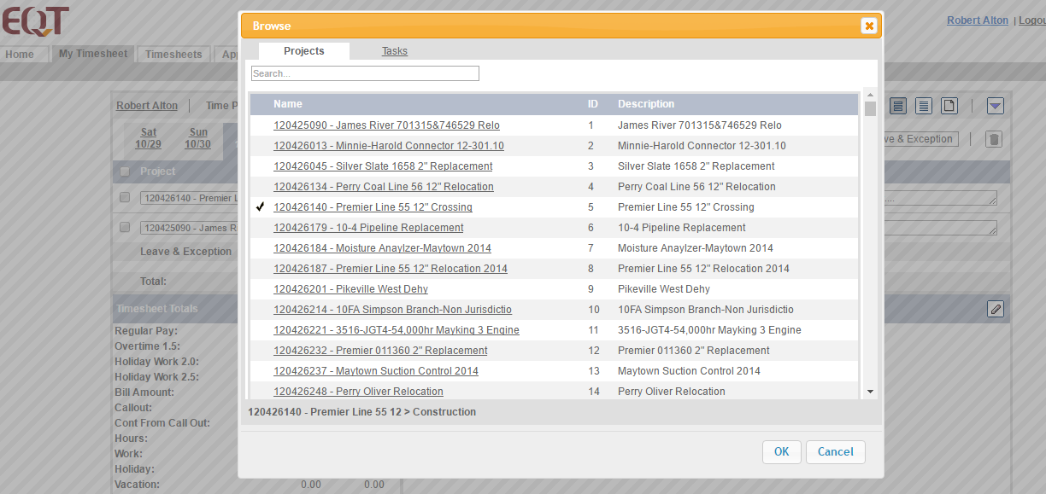

    - Select Work Item: Place a check mark next to the work item name. You can toggle to the task tab in the work item selection dialog box, search for and select a task as well. Click “okay” to add them to your timesheet.

  - Work Item Memorization: After saving Work Item hours, the timesheet memorizes work items you have used in your Work Item pick lists. Remember you can modify these memorization settings by going to your User Preferences and the modify the number of the last X work items you want your timesheet to remember.

Figure: Non-Exempt Timesheet
The timesheet provides a variety of data and various functions such as time period and calendar navigation, the ability to enter notes, copy previous data, delete data, save and submit your timesheet.

Figure 10: Non-Exempt Timesheet
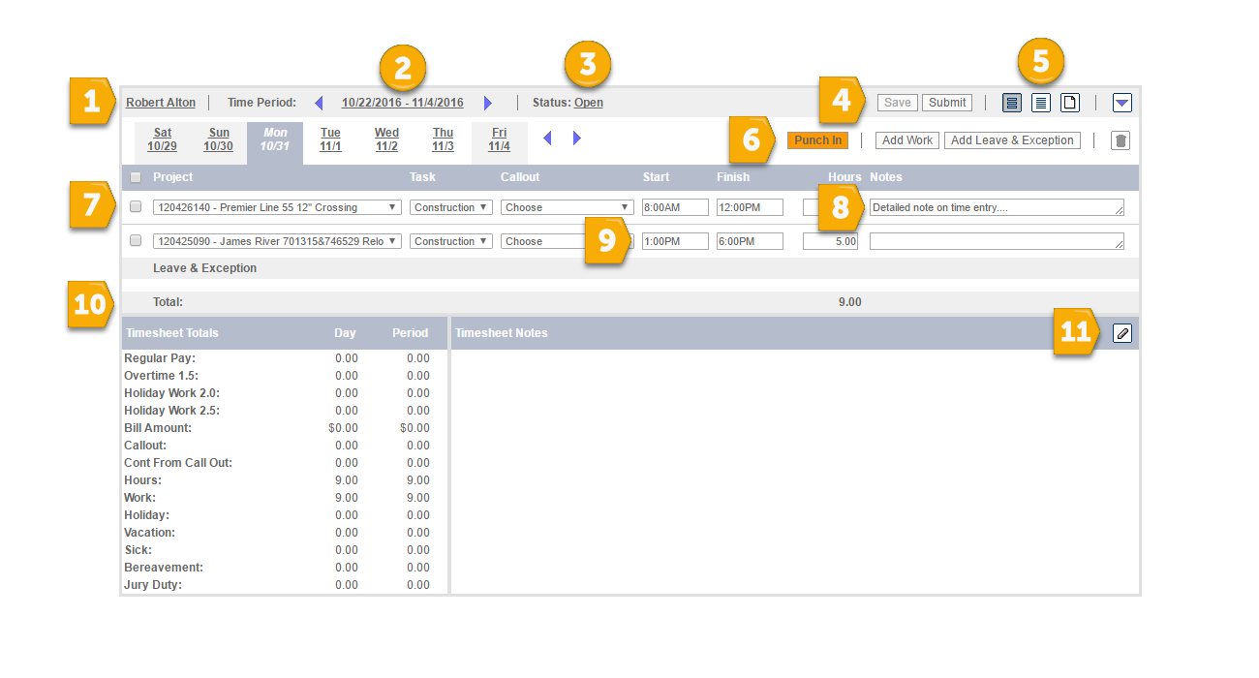

  - Employee Mini-Profile: You can view your system profile information by clicking on your name shown in (See 1 above).
  - Hourly Timesheets: For hourly timesheets, you can enter start times, finish times and hours for your project work using either of two methods (See 9).
    - Add Rows and Enter Start/Finish Times (see 6 and 9) You have the option to add work rows for each separate time entry. Select the project and task and enter or choose the appropriate start and finish times from the times pick list. The system will automatically calculate hours for each project/task.
    - Punch In/Punch Out: If you choose to click or tap the “punch in” or “punch out” orange button (See 6), the system will start and stop a stop watch that will calculate the duration of your time entry.
    - Rounding: When using the punch in and punch out buttons, the system will round your punches to the nearest fifteen minutes. If you punch in at 8:07 AM the system will round down to 8:00 AM. If you punch in at 8:08 AM the system will round up to 8:15 AM.

  - Exempt Timesheets:

Figure 12: Exempt Timesheet

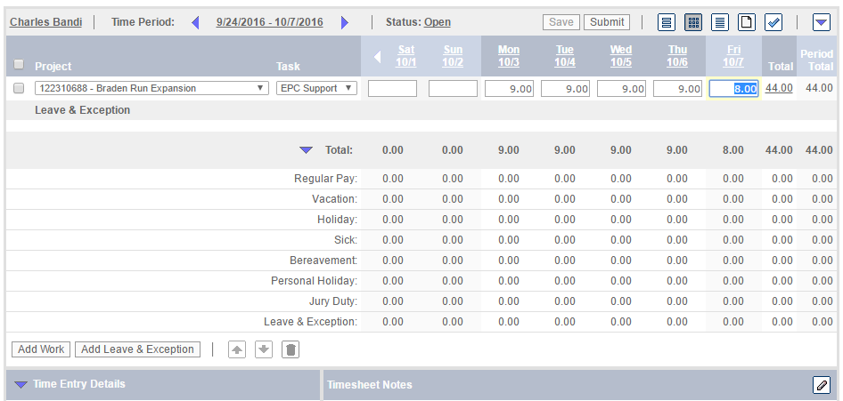
    - Using Add Work: Create time entries by clicking on Add Work. Enter work hours by clicking in the appropriate cells for each day and entering hours. (see 4) Depending upon your preferences, you can enter hours in integer format (e.g. 4.0) or an hours/minutes format (HH:MM). You should only enter hours values in these cells. Do not enter other text such as the word “Hours.” The system will round your entries to the nearest 15 minutes.

  - Entering Leave Hours:

Figure 13: Adding Leave & Leave Pick List
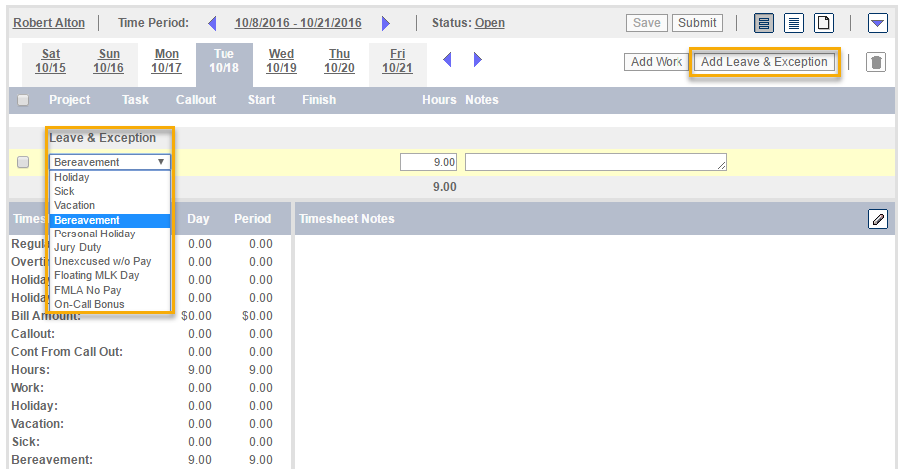

    - Leave Requests: If you have requested and received approval in advance for any leave, these hours will appear automatically be on your timesheet. To manually setup up Leave on your timesheet, click the Add Leave button and select the appropriate leave item from the pick list (see 5). Add Leave hours in the appropriate cell (see 6).

    - Adequate Leave Balances: You must have adequate Leave balances available for the system to accept your timesheet when you submit it. In this case you will get an error message saying you do not have the necessary Leave. Talk to your Supervisor about how to resolve this situation.

  - Viewing Future Timesheets: When trying to view future timesheets, note that you will have to click on the “Click Here” link first. This link will create the future timesheet and run background operations such as pushing scheduled holidays or approved leave hours onto the timesheet. You can always regenerate a future timesheet and re-run this operation by deleting the future timesheet and start over by clicking the “Click Here” link.

  - Timesheet must be valid: When you submit your timesheet, the system will provide clear validation error messages if you violate certain scheduled hours rules, minimum hours per day rules, maximum hours per day rules and more. Follow the instructions in the message, correct your timesheet and submit it again.
  - Adding Comments: You can add comments on an individual Work Item cell by clicking in the appropriate cell and entering up to 2,000 characters of comments or notes in the Time Entry Notes field on the bottom left of the screen. After saving these comments note that the cell is color coded (See 8 Above). Click on the “Timesheet Summary View” to see all time entries and their details such as comments (See 5 above).
  - Timesheet Comment: You can add comments about the entire time period, not just a particular time entry, by clicking on the pencil icon on the lower right of the screen. These should be comments about the entire week that you might want to highlight to your supervisor. Enter your comments and click save (See 11 above).

Step 5
Managing the Timesheet

- You can manage your timesheet in a variety of ways: re-order work item rows, delete rows, or delete the entire timesheet. You can also use last week’s timesheet as a template for the next week by using the copy previous feature.

  - Deleting Timesheet Rows: To delete a work item row(s), put check the box on the far left of any row(s) and click on the trash can icon. Doing this will delete all timesheet data on those rows and cannot be undone (See Row 6 below).
  - Deleting Entire Timesheet: (see below) You can also delete the entire timesheet and all its data by clicking on the upside down triangle. Deleting an entire timesheet cannot be undone.
  - Manually Copy Forward Timesheet Rows or Data: (See below) When you go to a new time period, you can copy previous work items, hours data or both by clicking on the upside down triangle.

Figure 14: Copy Previous/Delete Timesheet

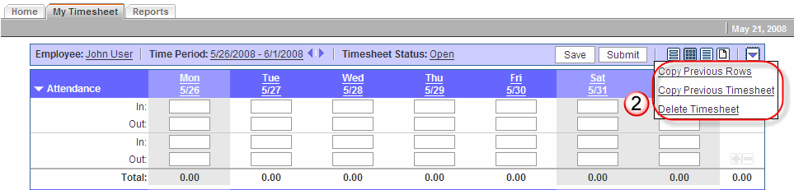

Step 6
Submitting the Timesheet
- Submitting Your Timesheet: When your timesheet is completed click on Submit (see 4 above). The timesheet will be locked from further editing until you unsubmit the timesheet. Once your timesheet is approved you cannot unsubmit it.

  - Timesheet Status: (See 3 above) You can view the status of your timesheet’s approvals by clicking on the Status link.

Step 7
Navigation the timesheet system

- Navigating Time Periods: You can navigate back or forward through time periods using the toggle buttons to the right of the current time period (see below).

  - When you click on the current time period link a calendar widget appears.

Figure 15: Calendar Navigation

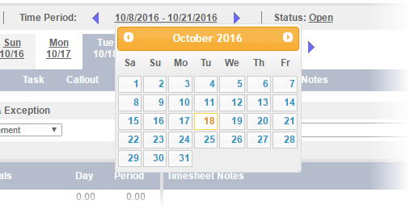

  - You can click on back and forward buttons to scroll through months and years of the calendar, and then select a date to view a timesheet.
  - If you click on an individual calendar date the timesheet containing that date with render.

If you have any more detailed questions, refer to the My Timesheet and Managing Timesheets Online Help topics or contact your supervisor or system administrator.

